Technical Architecture:

Project Design Phase-II

Technology Stack (Architecture & Stack)

|  |  |
| --- | --- |
| Date | 21 October 2022 |
| Team ID | PNT2022TMID11798 |
| Project Name | Project - Real-Time River Water Quality  Monitoring and Control System |
| Maximum Marks | 4 Marks |

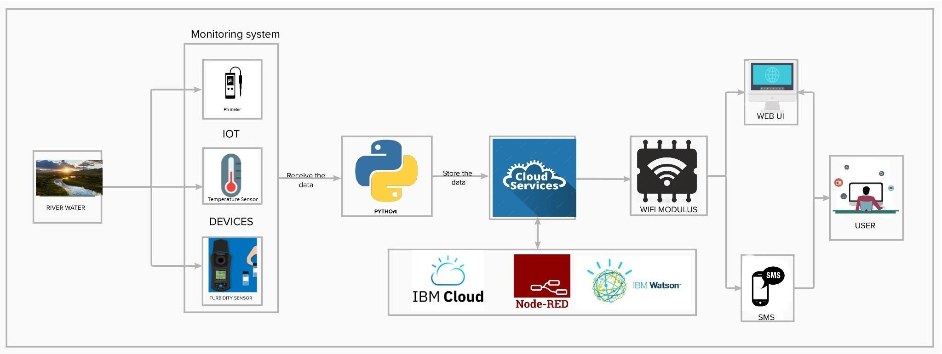

Table-1: Components & Technologies:

|  |  |  |  |
| --- | --- | --- | --- |
| **S.No** | **Component** | **Description** | **Technology** |
| 1. | User Interface | How user interacts with application e.g. Web UI, Mobile App etc. | HTML, CSS, JSP |
| 2. | Application Logic-1 | A page to upload images as input | Java / Python |
| 3. | Application Logic-2 | To use the Machine Learning model and predicting the result | IBM Watson STT service |
| 4. | Database | Data Type, Configurations etc. | MySQL, NoSQL, etc. |
| 5. | Cloud Database | Database Service on Cloud | IBM DB2, IBM Cloudant etc. |
| 6. | File Storage | To store data in a hierarchical structure | IBM Block Storage or Other Storage Service or Local Filesystem |
| 7. | Machine Learning Model | Here, we use a Support Vector Machine Algorithm that is used widely in Classification and Regression problems. | Object Recognition Model, etc. |
| 8. | Infrastructure (Server / Cloud) | Application Deployment on Local System / Cloud Local Server Configuration:  Cloud Server Configuration : | Local, Cloud Foundry, Kubernetes, etc. |

Table-2: Application Characteristics:

|  |  |  |  |
| --- | --- | --- | --- |
| **S.No** | **Characteristics** | **Description** | **Technology** |
| 1. | Open-Source Frameworks | List the open-source frameworks used | Technology of Opensource framework |
| 2. | Security Implementations | List all the security / access controls implemented, use of firewalls etc. | e.g. SHA-256, Encryptions, IAM Controls, OWASP etc. |
| 3. | Scalable Architecture | Justify the scalability of architecture (3 – tier, Micro- services) | Technology used |
| 4. | Availability | Justify the availability of application (e.g. use of load balancers, distributed servers etc.) | Technology used |
| 5. | Performance | Can extend the storage according to our needs | Python, AngularJS |